MEMBERSHIP WORKSHEET
For the Society of Mayflower Descendants
in the State of Delaware
I seek to apply for membership in this Society by right of bloodline descent from

who was a passenger on the MAYFLOWER voyage which terminated at Plymouth, New England, December, 1620
~ Send the worksheet to ACottle@UDel.Edu ~
Full, Complete Name of Applicant
Form of Name for Mailing

Residence of Applicant
Occupation of Applicant
Email Address
Telephone Number
Any information or evidence submitted to become a member will become the property of the General Society of Mayflower Descendants

STATEMENT OF LINE OF ELIGIBILITY FOR MEMBERSHIP
1
2 |  |  |  | who married
3 |  |  |  | who married
4 |  |  |  | who married
5 |  |  |  | who married

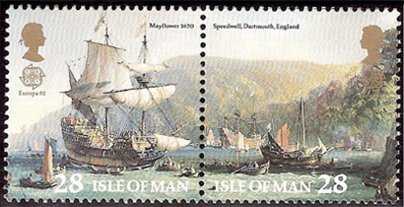

6
b.
d.
m.
married to
b.
d.
7
b.
d.
m.
married to
b.
d.

8
b.
d.
m.
married to
b.
d.

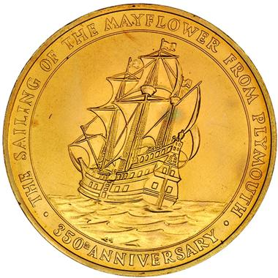

9
b.
d.
m.
married to
b.
d.

10
b.
d.
m.
married to
b.
d.
11
b.
d.
m.
married to
b.
d.

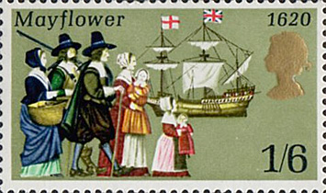

12
b.
d.
m.
married to
b.
d.
13
b.
d.
m.
married to
b.
d.
14
b.
d.
m.
married to
b.
d.

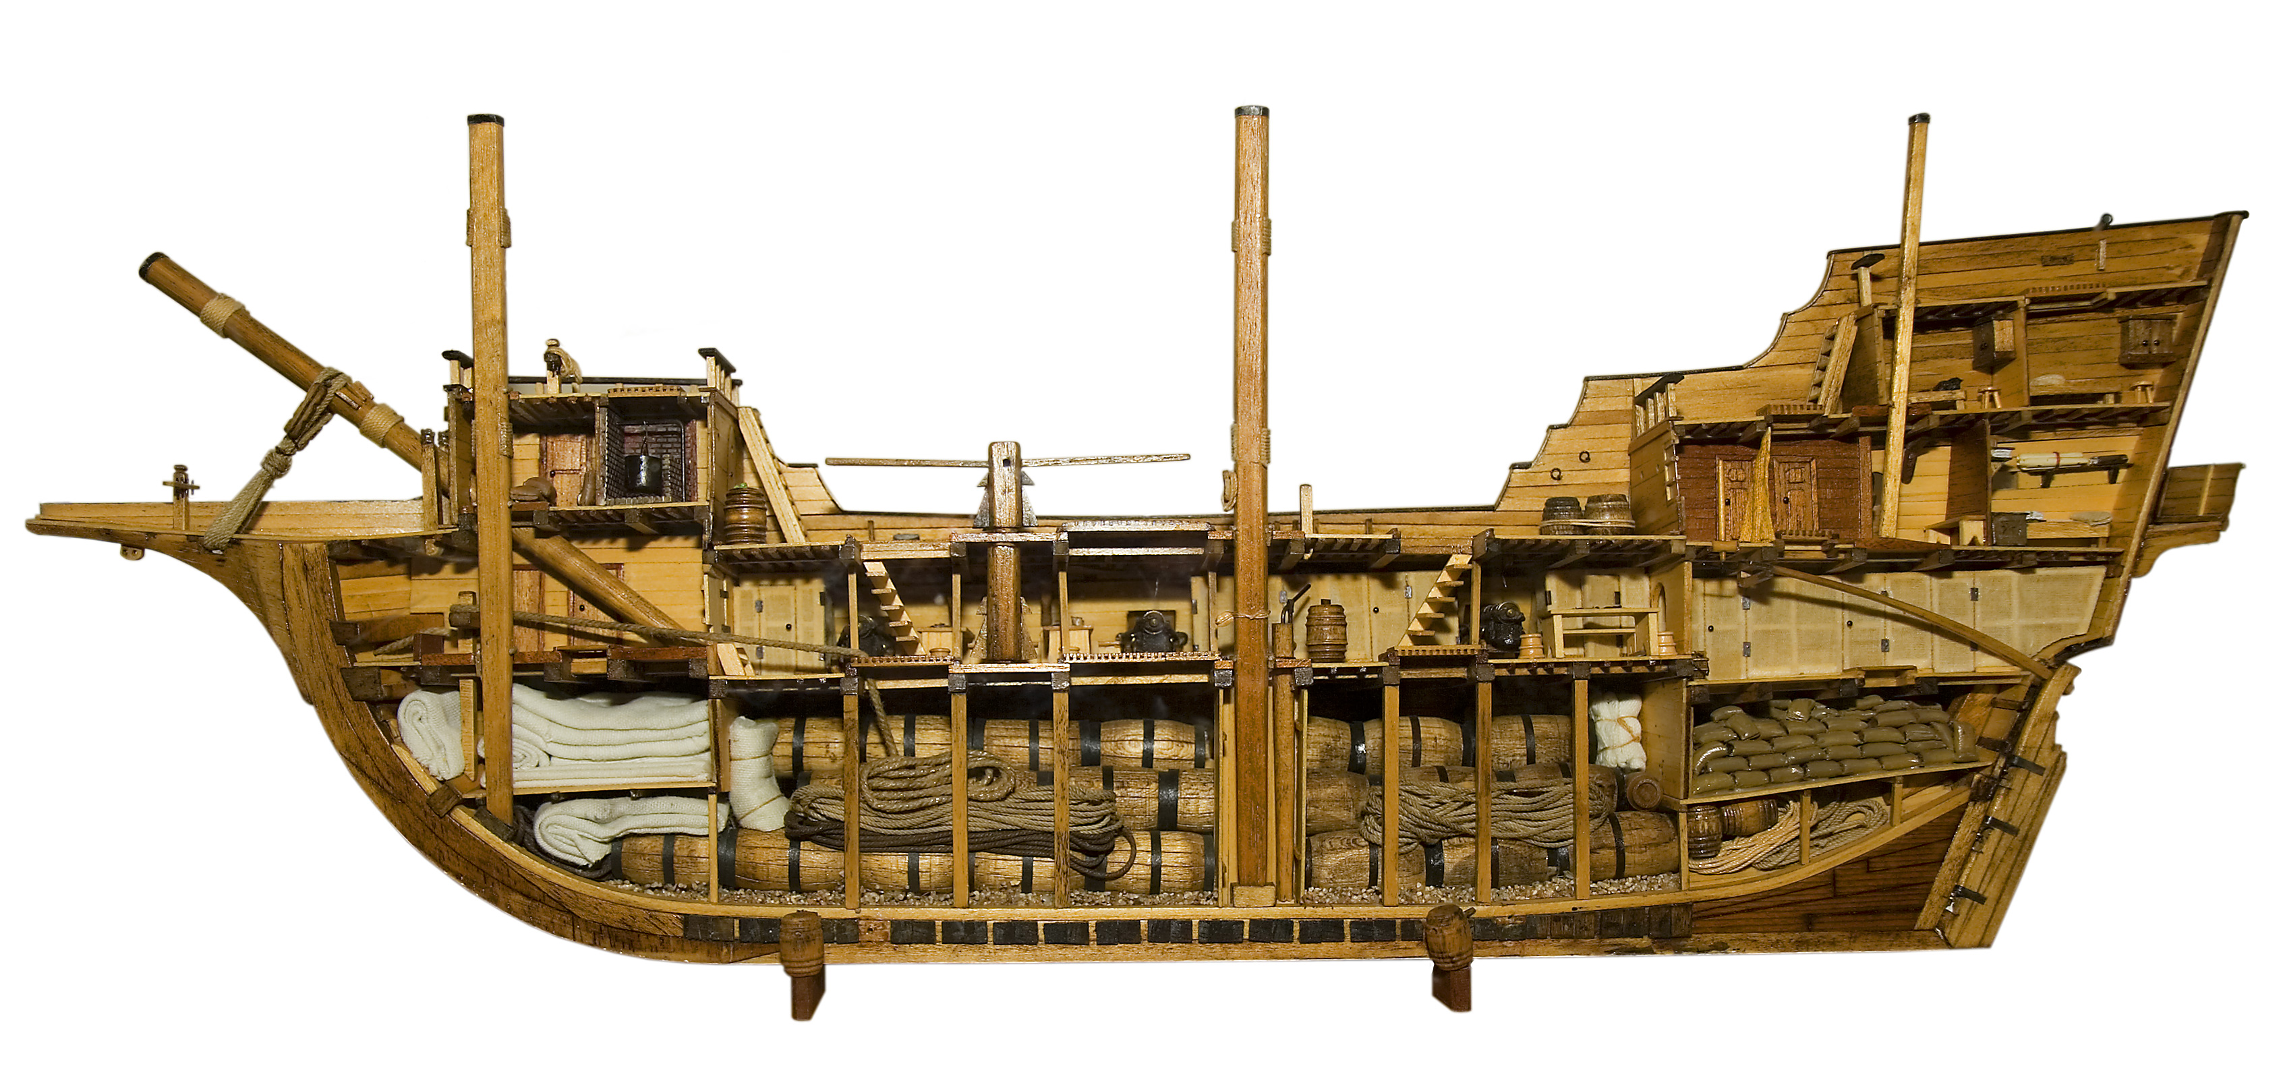

15
b.
d.
m.
married to
b.
d.

16
b.
d.
m.
married to
b.
d.
17
b.
d.
m.
married to
b.
d.

Society of Mayflower Descendants in the State of Delaware

